**Assignment 1-1: Basic File Structure**

Problem 1

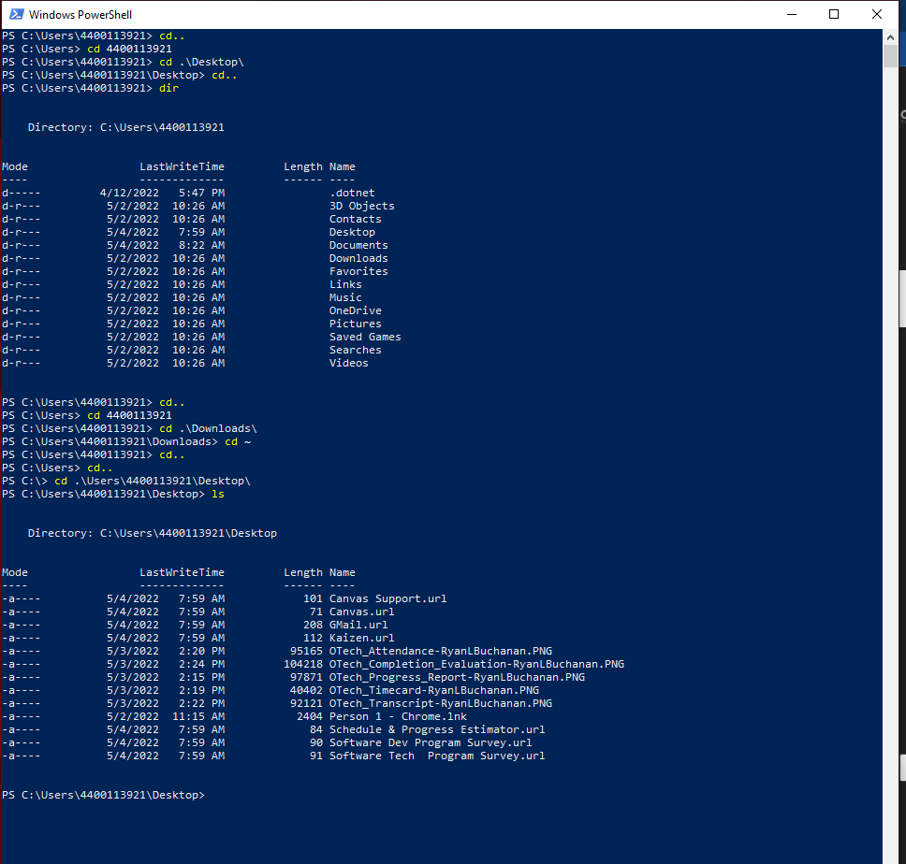

Problem 2

